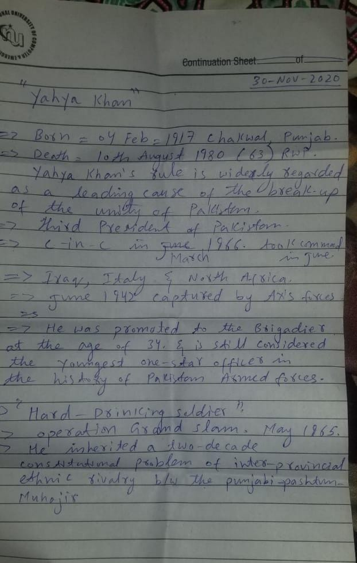

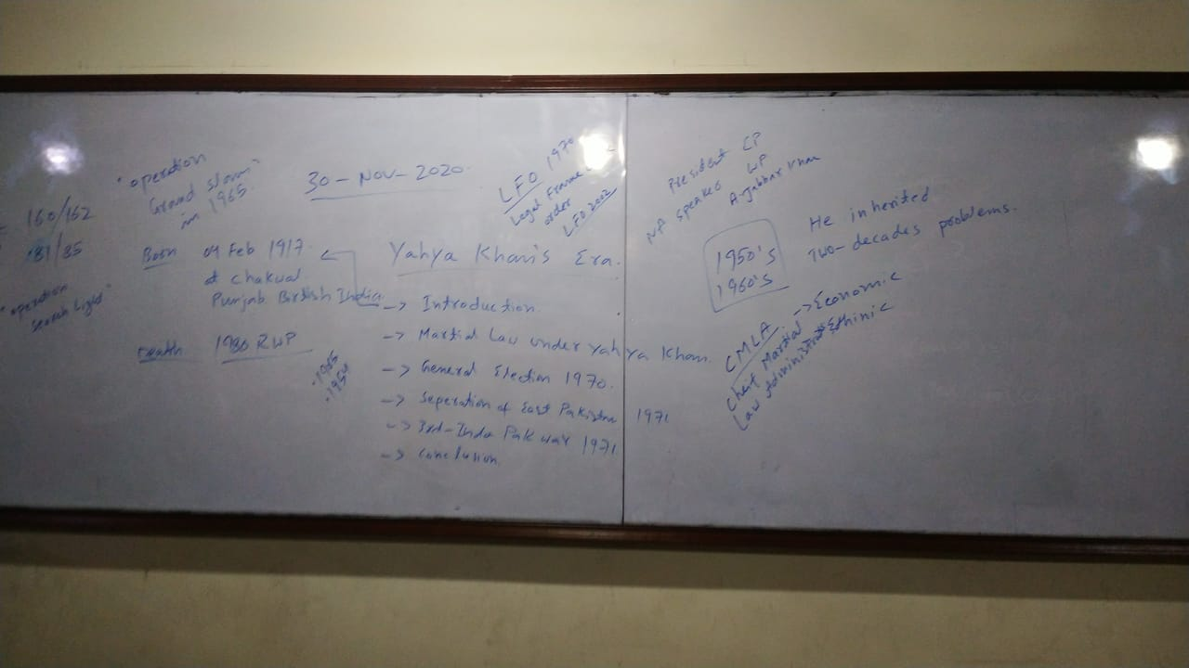

**Today's Lecture 30-11-2020.**

**Martial Law and The Restoration of Democracy.**

**1969-1977.**

**Yahya Khan 1913-1980**

Agha Muhammad Yahya Khan Urdu: آغا محمد یحییٰ خان‎;(4 February 1917 – 10 August 1980), widely known as Yahya Khan, was a Pakistani general who served as the third President of Pakistan, serving in this post from 25 March 1969 until turning over his presidency in December 1971.

Having participated in the Mediterranean theatre of World War II on behalf of Great Britain's British Indian Army, he opted for Pakistani citizenship and joined its military after the United Kingdom partitioned India in 1947, and helped in executing the covert infiltration in Indian Kashmir that sparked the war with India in 1965. After being controversially appointed to assume the army command in 1966, Yahya Khan took over the presidency from unpopular former dictator and elected President Ayub Khan, who was not able to deal with the 1969 uprising in East Pakistan, forced to resign by protests and offered him the office. Yahya Khan subsequently enforced martial law by suspending the constitution. Holding the nation's first nationwide elections in 1970, 23 years after independence, he delayed the power transition to victorious Sheikh Mujibur Rahman from East Pakistan, which further inflamed the civil violent unrest in the East, and authorized the East Pakistani authorities to violently suppress the rebellion in which, according to independent sources, between 300,000 and 500,000 people died in what is today widely considered the 1971 Bangladesh genocide.

Pakistan suffered a decisive defeat in the Bangladesh Liberation War of 1971, resulting in the dissolution of the Eastern Command of the Pakistan Army and the secession of East Pakistan as Bangladesh – thus Yahya Khan's rule is widely regarded as a leading cause of the break-up of the unity of Pakistan. Following these events, he turned over the leadership of the country to Zulfikar Ali Bhutto, the leading politician from West Pakistan, and resigned from the command of the military in disgrace, both on 20 December 1971. He was then stripped of his service honor’s and put under house surveillance for most of the 1970s.

After being released from these restrictions in 1977, he died in Rawalpindi in 1980. He is viewed largely negatively by Pakistani historians and is considered among the least successful of the country's leaders.

**Legal Framework Order.**

After the abrogation of the Constitution of 1962, Yahya Khan needed a legal framework to hold elections. In April and July 1969, he held discussions with prominent political party leaders to learn their point of view. Most of them asked for the revival of the Constitution of 1956 on the ground that its abrogation had been unlawful, and the country should return to the constitutional position prevailing on the eve of the 1958 coup. Yahya Khan initially agreed with this opinion, but had to change his stance due to opposition from the Awami League.

Not being well versed in constitutional affairs, he appointed a team to draft a new constitutional formula. He voiced his ideas about the constitutional issues in his broadcast address to the nation on November 28, 1969. The formula was officially issued on March 30, 1970, and is known as the Legal Framework Order of 1970. According to this order, One Unit was dissolved in West Pakistan and direct ballot replaced the principle of parity.

The National Assembly was to consist of 313 seats, including 13 seats reserved for women. Women were also allowed to contest the elections from general seats. The distribution of seats was to be as follows:

East Pakistan: 162 general and 7 reserved seats

Punjab: 82 general and 3 reserved seats

Sindh: 27 general and 1 reserved seat

N. W. F. P.: 18 general and 1 reserved seat

Baluchistan: 4 general and 1 reserved seat

Centrally Administered Tribal Areas: 7 general seats

The L. F. O. also defined the qualifications of people who would be allowed to contest in the elections. The Constituent Assembly was to stand dissolved if it was unable to frame the Constitution within 120 days. Actually, the Legal Framework Order was to act as an interim Constitution.

The primary function of the L. F. O. was to provide a setup on which elections could be conducted. It was then the duty of the elected Constituent Assembly to draft the Constitution of Pakistan. However, the L. F. O. defined the directive principles of State policy and made it clear that the future Constitution should not violate these basic principles. The directive principles demanded an Islamic way of life, observation of Islamic moral standards, and teaching of the Quran and Sunnah to the Muslims.

The Legal Framework Order also urged the Constituent Assembly to frame a Constitution in which Pakistan was to be a Federal Republic and should be named Islamic Republic of Pakistan. It also called for the preservation of Islamic Ideology and democratic values. The Constituent Assembly was also supposed to frame a Constitution in which all citizens of Pakistan were to enjoy fundamental human rights. Judiciary should remain independent from the Executive and provincial autonomy is protected.

The President was given the power to reject any Constitution framed by the Constituent Assembly if the document did not fulfill the above-mentioned requirements. The President also had the power to interpret and amend the Constitution, and his decision could not be challenged in a court of law.

**General Elections 1970**

The political history of Pakistan from 1947 to 1970 witnessed no general elections. Thus, when Yahya’s Regime decided to hold the first general elections on the basis of adult franchise at national level, they were not only required to make a new mechanism but were also required to set up a permanent election machinery. A three-member Election Commission was set up and Justice Abdus Sattar was appointed as the first Chief Election Commissioner of Pakistan.

The first task before the Election Commission was to enroll as voters all citizens of Pakistan who were at least 21-years old on October 1, 1969. The electoral rolls were put before the masses for corrections on January 16, 1970, and after necessary amendments, the final list was published on March 17. The total registered voters in the country were 56,941,500 out of which 31,211,220 were from the Eastern Wing, while 25,730,280 from the Western Wing. The Election Commission also marked the constituencies, in accordance with the seats allocated for the National and Provincial Assemblies under Legal Framework Order, 1970. One hundred and ninety-nine Returning Officers were appointed for the National Assembly and 285 Returning Officers were appointed for the Provincial Assemblies.

Twenty-four political parties participated in the elections. They were allowed to begin their election campaigns from January 1, 1970. The public meetings of Awami League in Bengal and Pakistan People’s Party in the Punjab and Sindh attracted huge crowds. Awami League mobilized support on the basis of its Six-Points Program, which was the main attraction in the party’s manifesto. While Z. A. Bhutto’s personality, his socialistic ideas and his slogan of “Rotti, Kapra aur Makan”, meaning food, clothing and shelter, were the factors that contributed to the popularity of Pakistan People’s Party. The rightist parties raised the religious slogans, while the leftists raised slogans based on regional and communistic ideas.

**The Separation of East Pakistan.**

The separation of East Pakistan was a great setback to Pakistan. By 1970, sentiments for national unity had weakened in East Pakistan to the extent that constant conflict between the two Wings dramatically erupted into mass civil disorder. This tragically resulted in the brutal and violent amputation of Pakistan’s Eastern Wing.

The physical separation of a thousand miles between the two wings without a common border, and being surrounded by Indian territory and influences, led to constant political, economic and social conflicts between the two wings; embittering relations bringing the country on the verge of collapse.

As a result of the separation of its Eastern Wing, Pakistan’s international credit was depleted and the military, being its most powerful institution, suffered a lot. To some, the very concept of Pakistan as the homeland for the Muslims in Southeast Asia no longer appeared valid.

Trouble started right at the inception of Pakistan in 1947. Almost immediately, East Pakistan claimed that as their population (55 percent as compared to 45 percent in the West) was greater, they were in a majority. Democratically, the Federal Capital, therefore, should have been in Dhaka and not in Karachi.

Since Karachi was the seat of the National Government; ministers, government officials and industrialists exerted immense influence on national and regional affairs, which brought them many benefits. But the East Pakistanis were unable to extract the same kind of advantages, as they were a thousand miles away from the Capital. Moreover, the Capital initially attracted wealthy industrialists, businessmen, administrators, doctors and other professionals who had fled from India.

The location of the Capital, it was said, created great economic imbalance, uneven distribution of national wealth and privileges, and better jobs for the people of West Pakistan, because they were able to sway decisions in their own favor.

Secondly, Bengalis resented the vast sums of foreign exchange earned from the sale of jute from East, which were being spent on defense. They questioned how the expenditure for the Kashmir cause would be justified, when it could otherwise have been productively used to build dams and barriers to control floods, eradicate poverty and illiteracy, and supply food and shelter for the ever-growing population in East Pakistan.

Thirdly, the people of the East believed that it was sheer regional prejudice that all white-collar jobs were taken by West Pakistanis.

Many mistakes were made early in the short history of Pakistan. There lived in East Pakistan about 15 million Hindus who, with the help of their fellow West Bengali Indians from across the border, were able to exploit East-West differences that emerged as a result of these mistakes. Grievances were exaggerated to foster anti-West Pakistani feelings that eventually created Bengali Nationalism and separatist tendencies. Bengali political leaders went around depicting the Central Government and West Pakistan as hostile exploiters. However, no effective efforts were made by the Government to check these anti-national trends.

Awami League, formed in 1951, was headed by Sheikh Mujib-ur-Rahman. He had always been an ardent Bengali nationalist. He began to attract popular support from Bengalis in East Pakistan. He put forward his Six Points that demanded more autonomy for the Provinces in general, and East Pakistan in particular. He was arrested in April 1966, and soon released, only to be rearrested and imprisoned in June the same year. He languished in prison until February 1969.

Being deeply aware of the explosive political situation in the country, the then Chief Martial Law Administrator, Yahya Khan, set in motion moves to transfer power to the elected representatives of the people, and announced that the general elections would be held on October 5, 1970.

In all his election speeches, Sheikh Mujib-ur-Rahman reiterated his demand for implementation of his Six Points and provincial autonomy plans.

The 1970 elections were postponed from October to December due to heavy floods that caused immense destruction and havoc in East Pakistan. The sheer enormity of the disaster attracted worldwide attention. This gave Sheikh Mujib-ur-Rahman a golden opportunity to have an international audience for his anti-West Pakistan feelings, which he accused of brutal callousness. The Awami League gained much sympathy and benefit out of this suffering, and Sheikh Mujib-ur-Rahman and his people were portrayed on the international scene as victims of West Pakistan’s indifference.

In the general elections held in December 1970, the Awami League achieved an overwhelming victory. They captured 167 seats, the highest number in East Pakistan and overall. In the West, the Pakistan People’s Party had won 85 seats. The way was now open to draw up a new Constitution.

The Awami League, now overwhelmingly victors, stood firm on its Six Points plan and refused to compromise on that issue. The Peoples Party in the West maintained that the Six Points Program did not really permit a genuine federation. It was in fact a unique constitutional proposal that proposed a federation that had power only over defense and foreign policy.

Efforts were made to start a constitutional dialogue and narrow the differences between the two Wings, but all in vain. Mujib-ur-Rahman’s adamant stand in support of his Six Points, and his proposal that East Pakistan should have a sovereign status independent of Pakistan, further aggravated the situation.

Mujib-ur-Rahman launched a non-cooperation movement. The civil administration was totally paralyzed. All government and educational institutions were closed.

People were asked not to pay any taxes. The transport system came to a standstill. Factories and shops were shut. All government activities between both the Wings ceased. The Awami League setup a parallel government. Gangs of local Awami League freedom fighters, known as Mukti Bahini, led violent demonstrations and howled racial and anti-West Pakistan slogans, inciting the people to more violence.

Amidst these disturbances, General Yahya decided to convene the National Assembly in March 1971. But Sheikh Mujib-ur-Rahman unexpectedly put forward other demands such as the immediate lifting of Martial Law and power transfer to the elected representatives of the people, prior to the National Assembly session.

Unfortunately, on March 23, the Republic Day of Pakistan, the Awami League declared “Resistance Day” and Bangladesh flags flew all over the Province. There was a great massacre. East Pakistan had reached a point of no return. To quash the armed rebellion of Awami League militants, the Pakistan Army struck its first blow on March 27, 1971. Yahya Khan chose to use force to bring law and order in the country.

In the meantime, India exploited Pakistan’s dilemma to the full. It sought to wring full propaganda and strategic value for itself out of the Bengali suffering and misery. India launched an attack on East Pakistan on November 22, 1971. The use of modern Soviet missiles, geographical separation by a thousand miles lying across the hostile Indian territory, and the collusion of Mukti Bahini and the Indian Army, made Pakistan’s military defeat in the East almost certain.

On December 10, 1971, the first feeler for surrender in East Pakistan was conveyed to the United Nations. On December 17, 1971, a formal surrender was submitted and accepted. Forty-five thousand troops and an almost equal number of civilians of West Pakistan were taken as prisoners of war.

The text of the Instrument of Surrender document was as follows:

**“INSTRUMENT OF SURRENDER”**

The PAKISTAN Eastern Command agree to surrender all PAKISTAN Armed Forces in BANGLA DESH to Lieutenant-General JAGJIT SINGH AURORA, General Officer Commanding in Chief of the Indian and BANGLA DESH forces in the Eastern Theatre. This surrender includes all PAKISTAN land, air and naval forces as also all para-military forces and civil armed forces. These forces will lay down their arms and surrender at the places where they are currently located to the nearest regular troops under the command of Lieutenant- General JAGJIT SINGH AURORA.

The PAKISTAN Eastern Command shall come under the orders of Lieutenant-General JAGJIT SINGH AURORA as soon as this instrument has been signed. Disobedience of orders will be regarded as a breach of the surrender terms and will be dealt with in accordance with the accepted laws and usages of war. The decision of Lieutenant-General JAGJIT SINGH AURORA will be final, should any doubt arise as to the meaning or interpretation of the surrender terms.

Lieutenant- General JAGJIT SINGH AURORA gives a solemn assurance that personnel who surrender will be treated with dignity and respect that soldiers are entitled to in accordance with the provisions of the GENEVA Convention and guarantees the safety and well-being of all PAKISTAN military and para-military forces who surrender. Protection will be provided to foreign nationals, ethnic minorities and personnel of WEST PAKISTAN origin by the forces under the command of Lieutenant- General JAGJIT SINGH AURORA.

Signed:

(JAGJIT SINGH AURORA) Lieutenant-General General Officer Commanding in Chief Indian and BANGLA DESH Forces in the Eastern Theatre

(AMIR ABDULLAH KHAN NIAZI) Lieutenant-General Martial Law Administrator Zone B and Commander Eastern Command (PAKISTAN)

**16 December 1971″**

The surrender led to the disintegration of East and West Pakistan and the establishment of Bangladesh. After 25 years, the East Pakistanis declared themselves independent and renamed their Province as Bangladesh. Pakistan finally recognized Bangladesh at the Islamic Conference in Lahore on February 22, 1974.